**Docker IPvlan L3 Mode (Layer 3)**

In L3 mode, containers are placed on a Layer 3 network, which means they need to be routed to communicate with the host or other containers. In this mode, containers communicate by routing traffic through a router rather than simply switching traffic at Layer 2.

**Features:**

Containers are placed in different Layer 3 networks (subnets), so communication between them requires routing.

There is no Layer 2 broadcast domain between containers; they are isolated at Layer 3 and need routing for inter-container communication.

Suitable when you want containers to operate in different IP subnets or when you need more granular control over routing between containers.

**Use Case:**

Ideal when you need to implement routing between containers and host interfaces.

Useful in larger-scale, routed network environments, where multiple subnets or complex routing policies are needed.

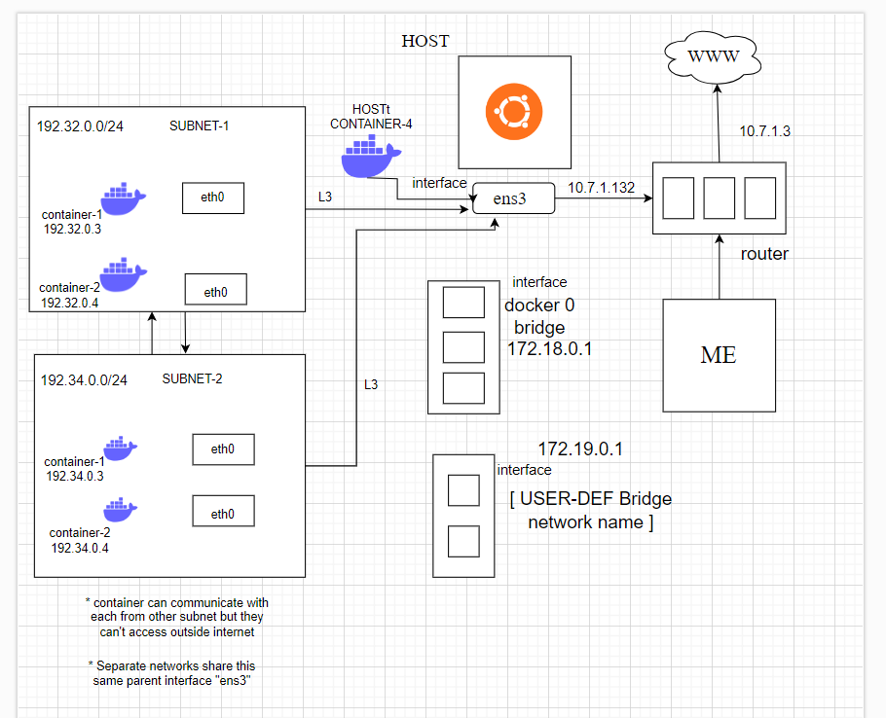

**Create an IPvlan L3 network**:

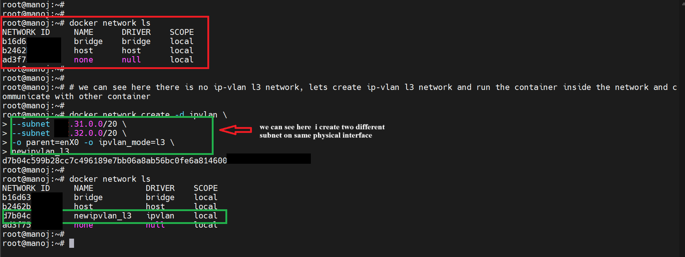

**Run a container in the IPvlan L3 network:**

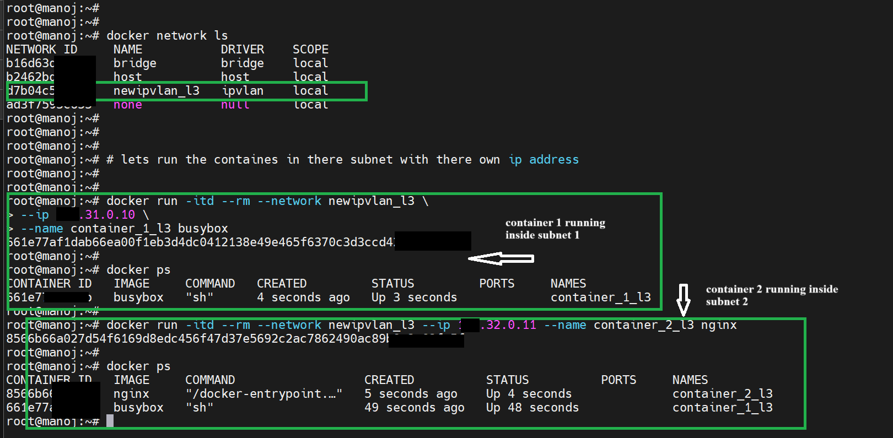

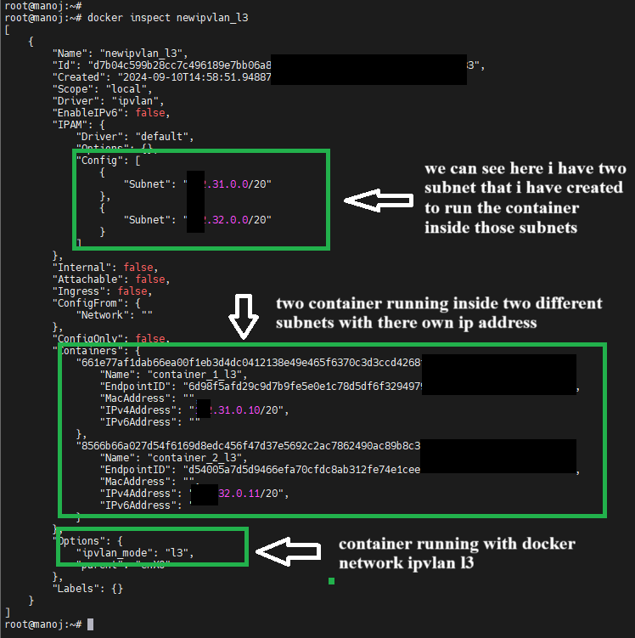

We can see container are isolated from the outside network. But we can communicate with in the same network.

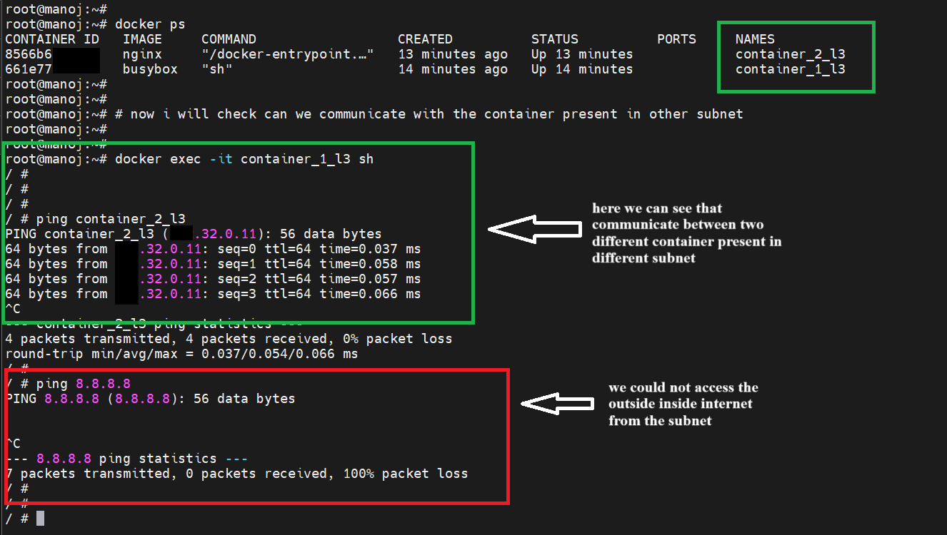

**Docker IPvlan L2 Mode (Layer 2)**

In L2 mode, the containers operate like traditional Ethernet devices on the same network as the parent interface. Each container gets its own IP address and behaves like it's directly connected to the same physical or virtual network as the host.

**Features:**

Containers appear as devices on the same Layer 2 broadcast domain (same VLAN or subnet).

Containers share the MAC address of the host’s parent network interface.

Suitable when you want containers to operate on the same LAN or VLAN as the host, without needing to deal with routing.

**Use Case:**

Ideal when you want containers to be part of the same local network (same subnet) as the host.

Good for environments where you want minimal network overhead and direct connectivity.

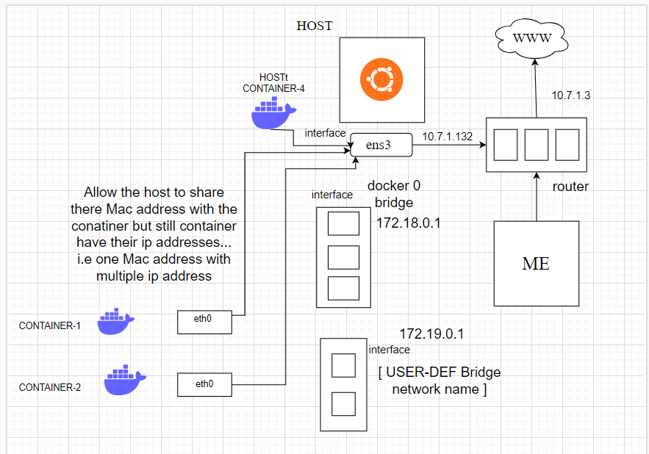

**Create an IPvlan L2 network**:

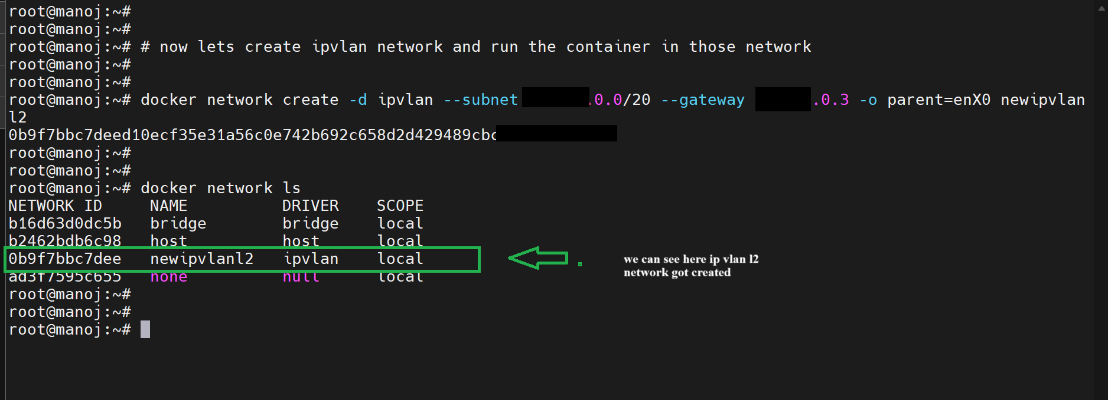

**Run a container in the IPvlan L2 network**:

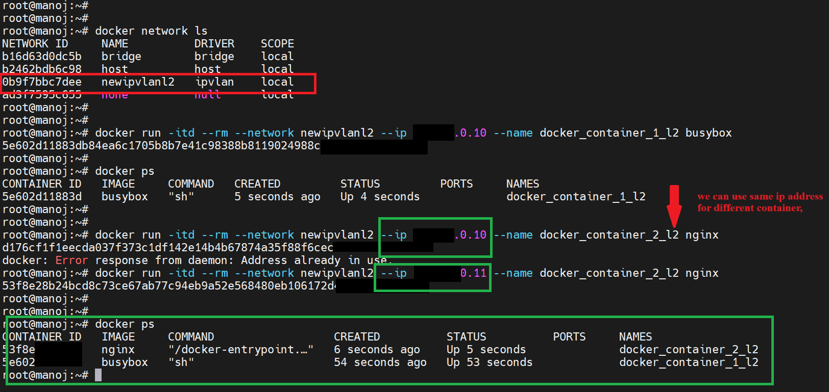

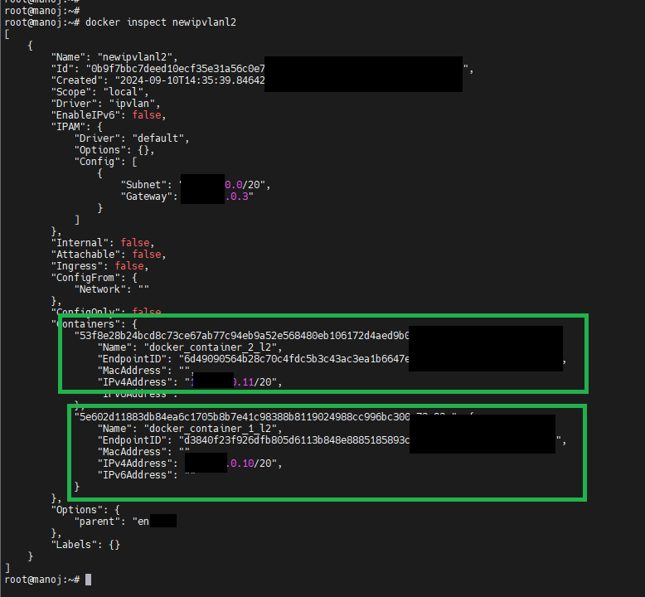

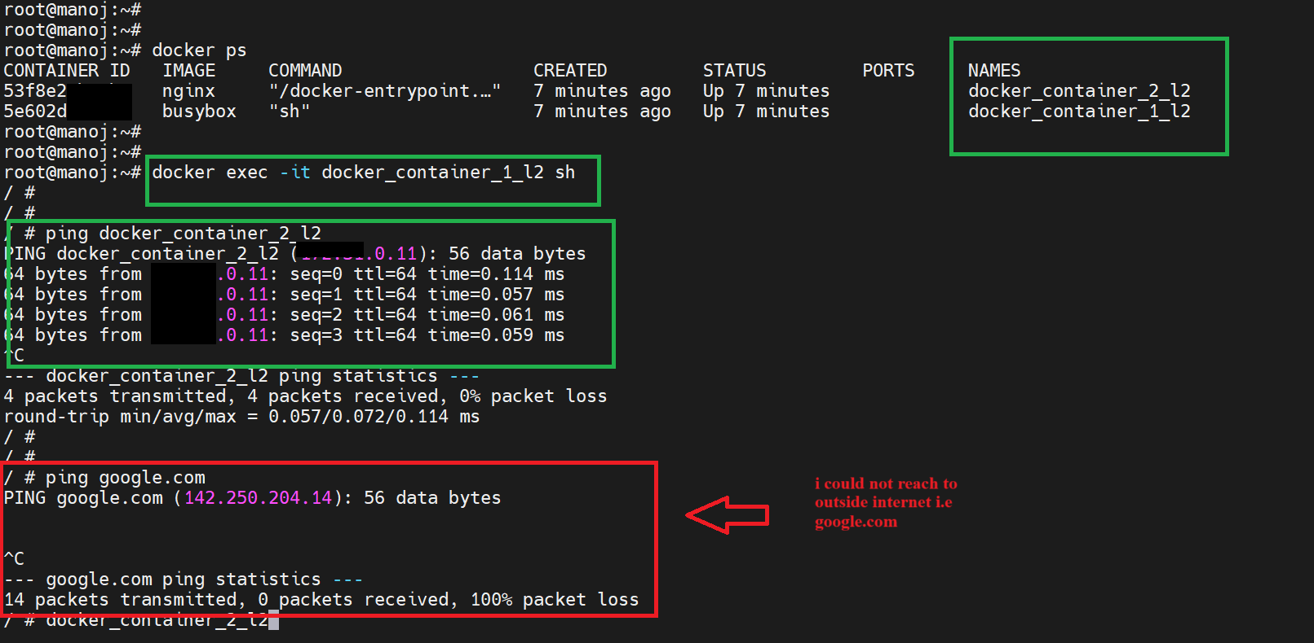

**Key Differences Between IPvlan L2 and L3:**

| **Feature** | **IPvlan L2 (Layer 2)** | **IPvlan L3 (Layer 3)** |
| --- | --- | --- |
| Communication | Works on Layer 2, same broadcast domain as the host | Works on Layer 3, requires routing between containers |
| MAC Address | Uses the host's MAC address | Does not require MAC addresses for containers |
| Network | Containers operate in the same subnet | Containers can be in different subnets |
| Use Case | Simple, direct access to the same LAN | More control over routing between containers |
| Complexity | Easier to set up, fewer routing concerns | Requires routing configuration |

**When to Use Each Mode:**

* Use IPvlan L2 mode when you want containers to be on the same Layer 2 network (like a local LAN or VLAN) and you need them to have minimal routing overhead.
* Use IPvlan L3 mode when you want to isolate containers at Layer 3 and implement routing between subnets or across different network zones.